Match the historical landmark to the correct country:

1. Tsarevets Fortress in Veliko Tarnovo:

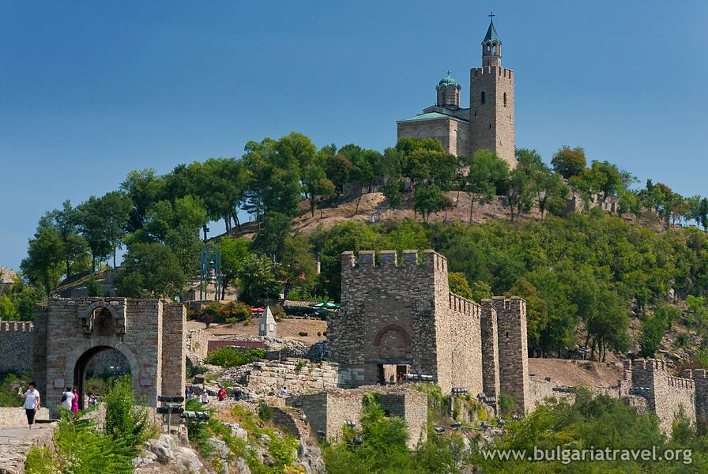

a. Bulgaria

b. Italy

c. Poland

d. Romania

Answer: a

2. Ancient Theatre in Plovdiv

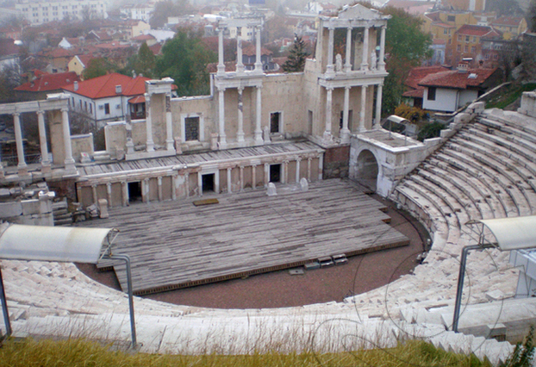

a. Sweden

b. Bulgaria

c. Spain

d. Turkey

Answer: b

3. Rila Monastery

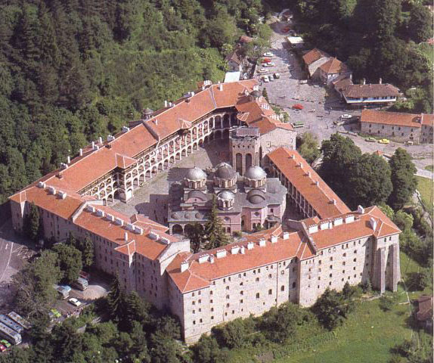

a. Bulgaria

b. Romania

c. Italy

d. Spain

Answer: a

4. Madara Horseman

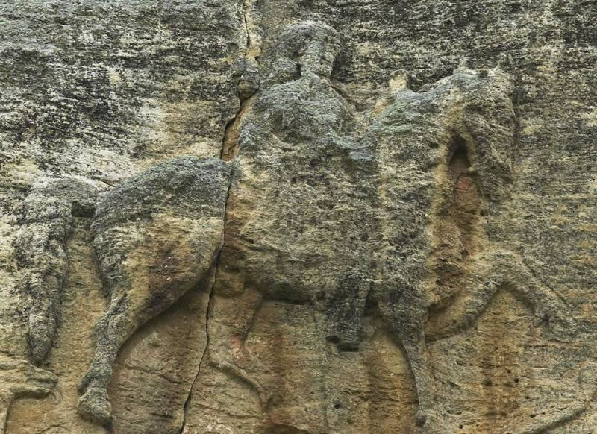

a. Spain

b. Bulgaria

c. Turkey

d. Romania

Answer: b

5. Shipka Memorial

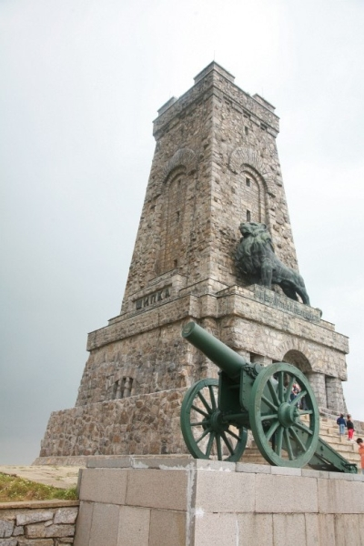

a. Italy

b. Sweden

c. Bulgaria

d. Poland

Answer: c

**Sources:**

**Tsarevets Fortress**

<http://bulgariatravel.org/bg/object/5/Carevec>

<http://bg.wikipedia.org/wiki/%D0%A6%D0%B0%D1%80%D0%B5%D0%B2%D0%B5%D1%86>

**Ancient Theatre in Plovdiv**

<http://bg.wikipedia.org/wiki/%D0%90%D0%BD%D1%82%D0%B8%D1%87%D0%B5%D0%BD_%D1%82%D0%B5%D0%B0%D1%82%D1%8A%D1%80_%28%D0%9F%D0%BB%D0%BE%D0%B2%D0%B4%D0%B8%D0%B2%29>

**Rila Monastery**

<http://bg.wikipedia.org/wiki/%D0%A0%D0%B8%D0%BB%D1%81%D0%BA%D0%B8_%D0%BC%D0%B0%D0%BD%D0%B0%D1%81%D1%82%D0%B8%D1%80>

**Madara Horseman**

<http://bg.wikipedia.org/wiki/%D0%9C%D0%B0%D0%B4%D0%B0%D1%80%D1%81%D0%BA%D0%B8_%D0%BA%D0%BE%D0%BD%D0%BD%D0%B8%D0%BA>

**Shipka Memorial**

<http://bg.wikipedia.org/wiki/%D0%A8%D0%B8%D0%BF%D0%BA%D0%B0_%28%D0%B2%D1%80%D1%8A%D1%85%29>